OLVIDA, JV Christian A.

2011 – 15253

LIS 161 Final Project

Project Description: Inventory Management and Automated Invoice Generator System

My vision for this project was to develop an inventory management and automated invoice generator system for the online-selling business that I am working on. My goal was to create a system that would help me manage my product inventory and generate receipts for customer purchases.

The inventory management module should allow me to input and store product information such as product name, price, and quantity. I envisioned the system providing a user-friendly interface where I could easily update and track the availability of products and their corresponding stock levels to ensure that I would always be aware of the products available for sale. On the other hand, I envisioned the automated invoice generator module to simplify the process of generating receipts for customer purchases. However, due to the challenges faced during development, this particular component has not been completed. The intended functionality of the invoice generator is to automatically generate receipts based on the customer's purchase details. This would include capturing the customer's information, such as their name and contact details, as well as the purchased items, quantities, prices, and total amount paid, the system would then generate a receipt.

The future development of this project will focus on resolving the challenges encountered during the development of the invoice generator component. This may involve seeking assistance from programming communities and consulting with experienced developers. By completing the invoice generator functionality, the system will provide a comprehensive solution, automating the process of generating receipts for customer purchases.

Overall, this project aims to provide an efficient and user-friendly solution for inventory management and automated invoice generation suitable for personal online businesses. The system will be able to assist users in effectively managing their product inventory and simplifying the process of generating receipts for customer purchases, enhancing the overall efficiency and professionalism of their business operations.

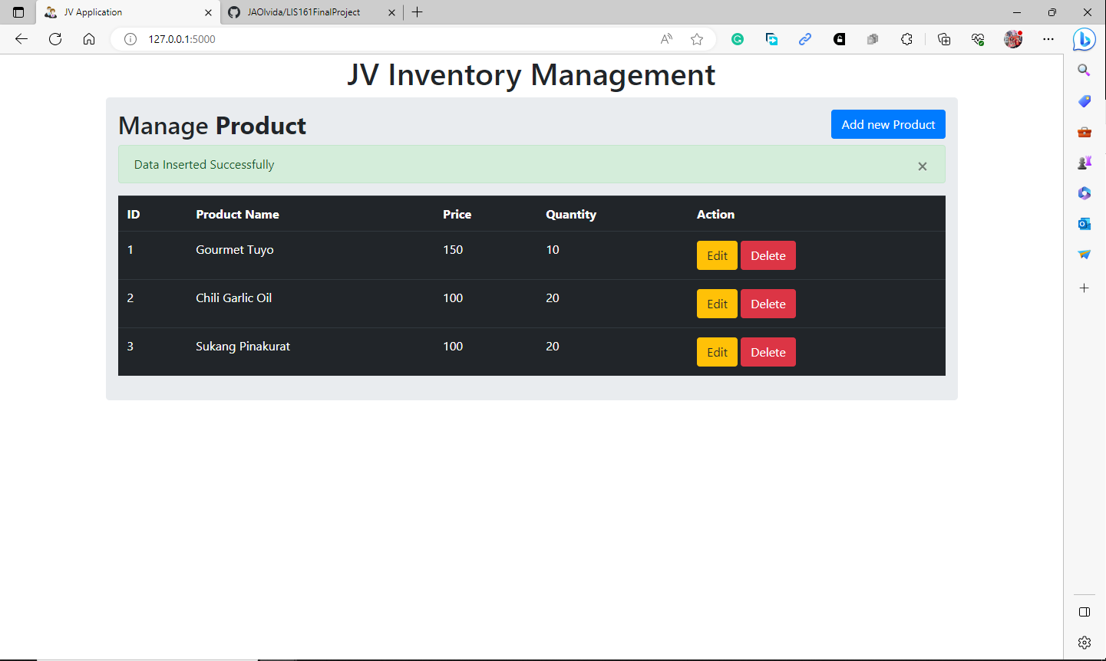

Image 1: Program Interface

Image 2: Command prompt after clicking the ‘Add new Product’ button

Image 3: Command prompt after clicking the ‘Edit’ button

Image 4: Command prompt after clicking the ‘Delete’ button